ServiceNow Metro Ticket Generating System
Project Documentation

1. Project Overview
The Metro Ticket Generating System is a ServiceNow-based application developed to simplify the process of booking metro tickets. The system allows users to select the starting station, destination station, journey type, number of passengers, and payment mode. The application automatically calculates the ticket fare based on the selected route, journey type, and number of passengers. The system also provides QR code generation for the metro ticket through a Service Portal widget.

2. Objectives
- To develop a simple metro ticket booking system using ServiceNow.
- To provide starting and destination station selection.
- To calculate the ticket fare automatically.
- To support single and return journeys.
- To calculate fares based on the number of passengers.
- To provide different payment options.
- To generate a QR code for the metro ticket.
- To provide a simple and user-friendly ticket booking interface.

3. Technologies Used
- ServiceNow
- Service Catalog
- Catalog Client Scripts
- Catalog UI Policies
- Service Portal
- Service Portal Widgets
- JavaScript
- Update Sets

4. System Components

ServiceNow Catalog Item Configuration
The Book A Metro Ticket catalog item is created in ServiceNow under the Services category. It provides the main interface for users to book metro tickets by entering journey details and payment information.
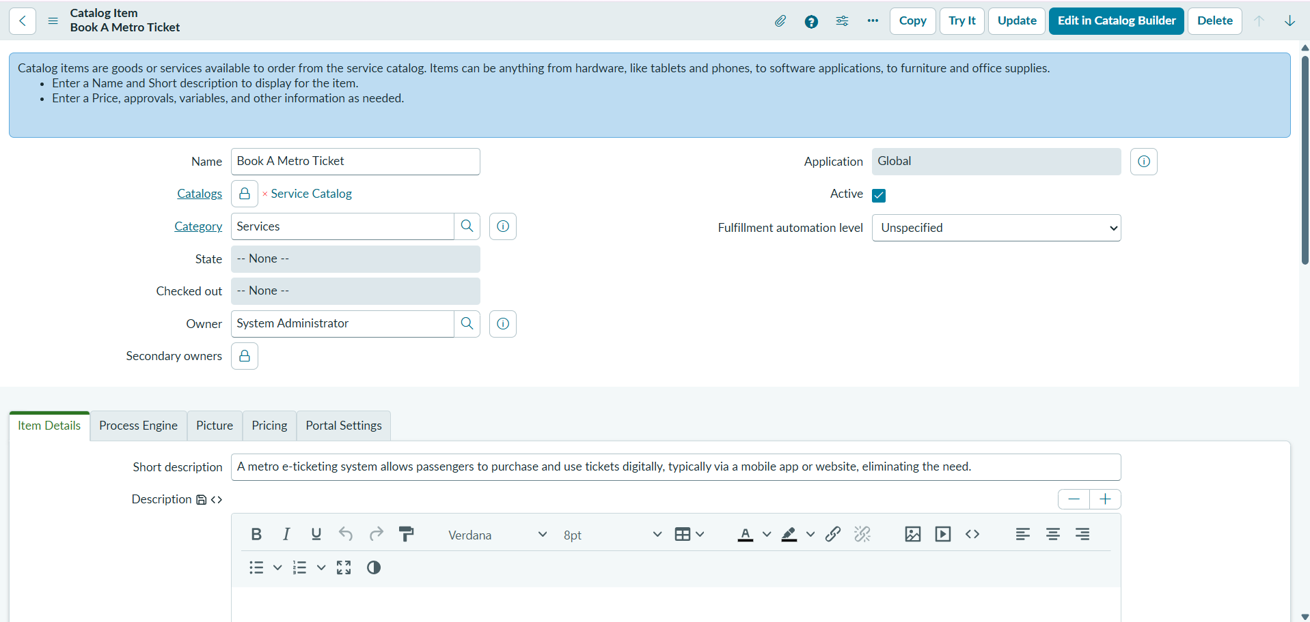
Book A Metro Ticket – Catalog Item Configuration

Catalog Variables
This screen shows the eight variables configured for the catalog item: Starting From, Going To, Type of Journey, No of Passengers, Amount for Single Journey, Amount Including Return, Mode of Payment, and Enter Payment Mode. These variables collect the information required to process a ticket request.

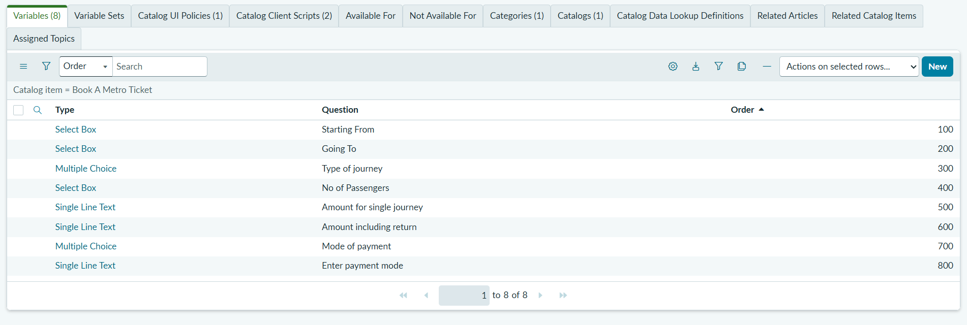
Variables Configured for Book A Metro Ticket

Catalog UI Policy
The Fields Visibility Catalog UI Policy is configured to control the visibility and behavior of fields in the metro ticket booking form. It helps display the relevant payment field according to the configured conditions.

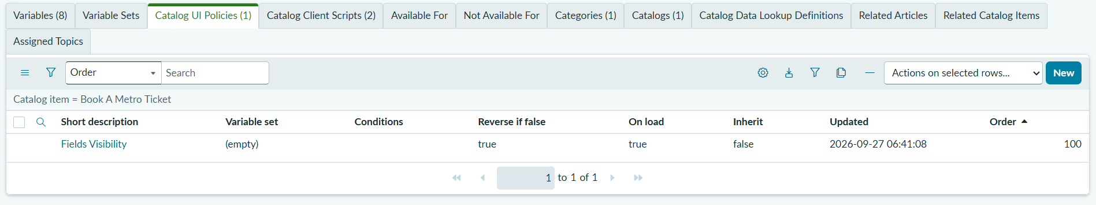
Fields Visibility UI Policy Configuration

Catalog Client Scripts
This screen displays the two active Catalog Client Scripts: Fare auto-calculation and QR Generation. The fare script calculates ticket costs based on the selected journey details, while the QR Generation script supports the ticket QR-code process during submission.
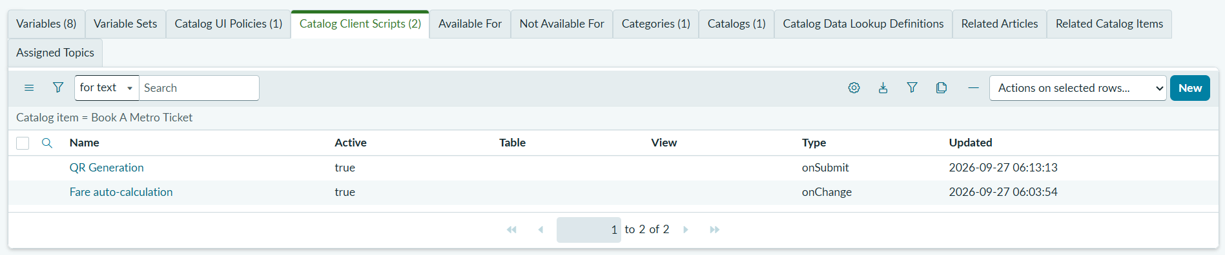
Fare Auto-calculation and QR Generation Scripts

ServiceNow Catalog Search
The ServiceNow search page displays the results for the keyword “metro.” Users can find and open the Book A Metro Ticket catalog item directly from the search results.

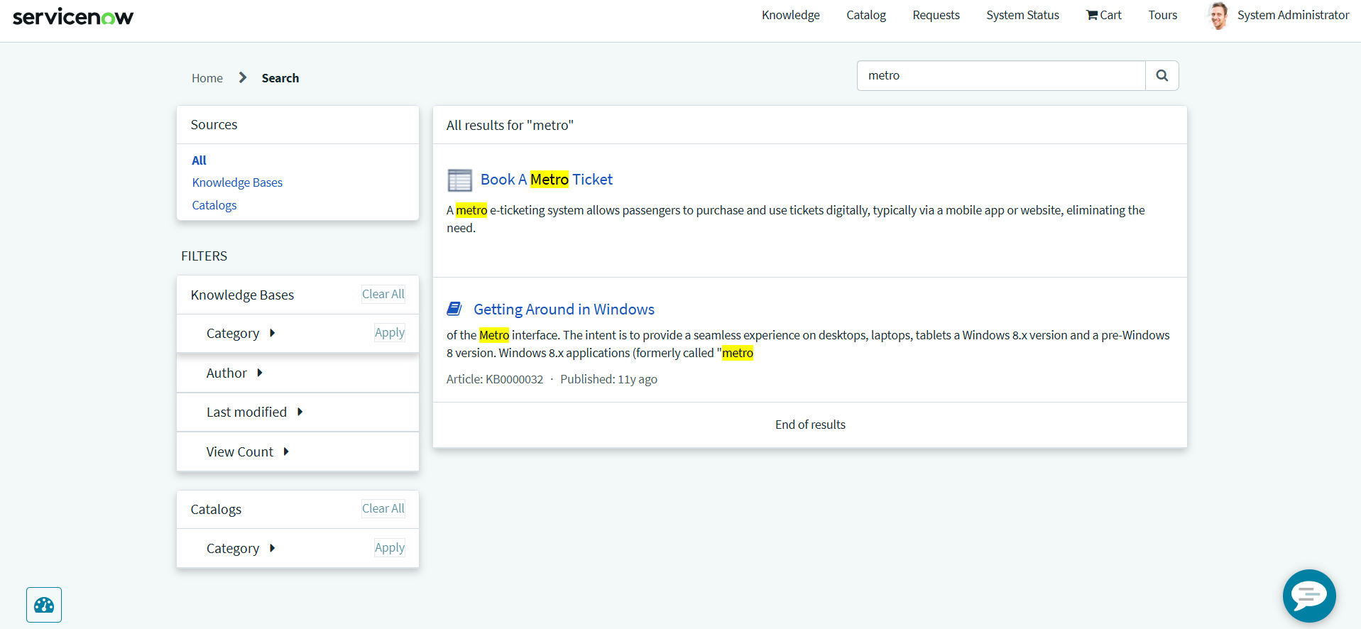
Search Results for Metro Ticket Booking

Metro Ticket Booking Form
The booking form allows users to select the starting station, destination station, journey type, and number of passengers. The system calculates the fare according to the selected route and passenger count.
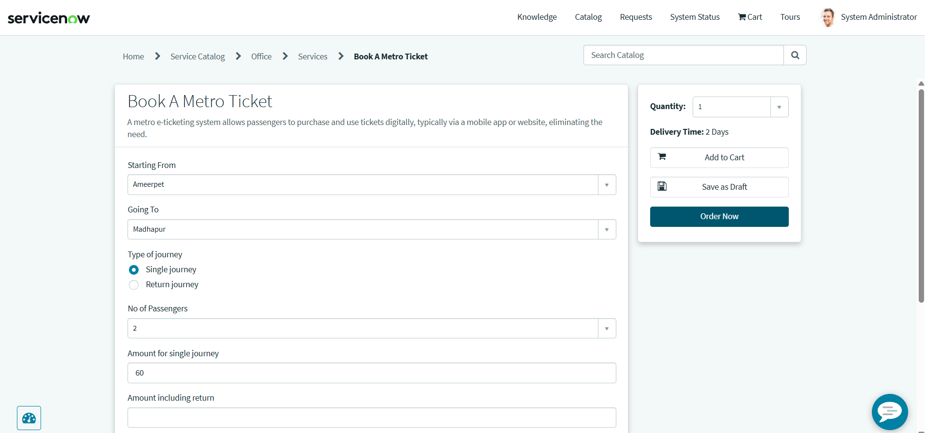
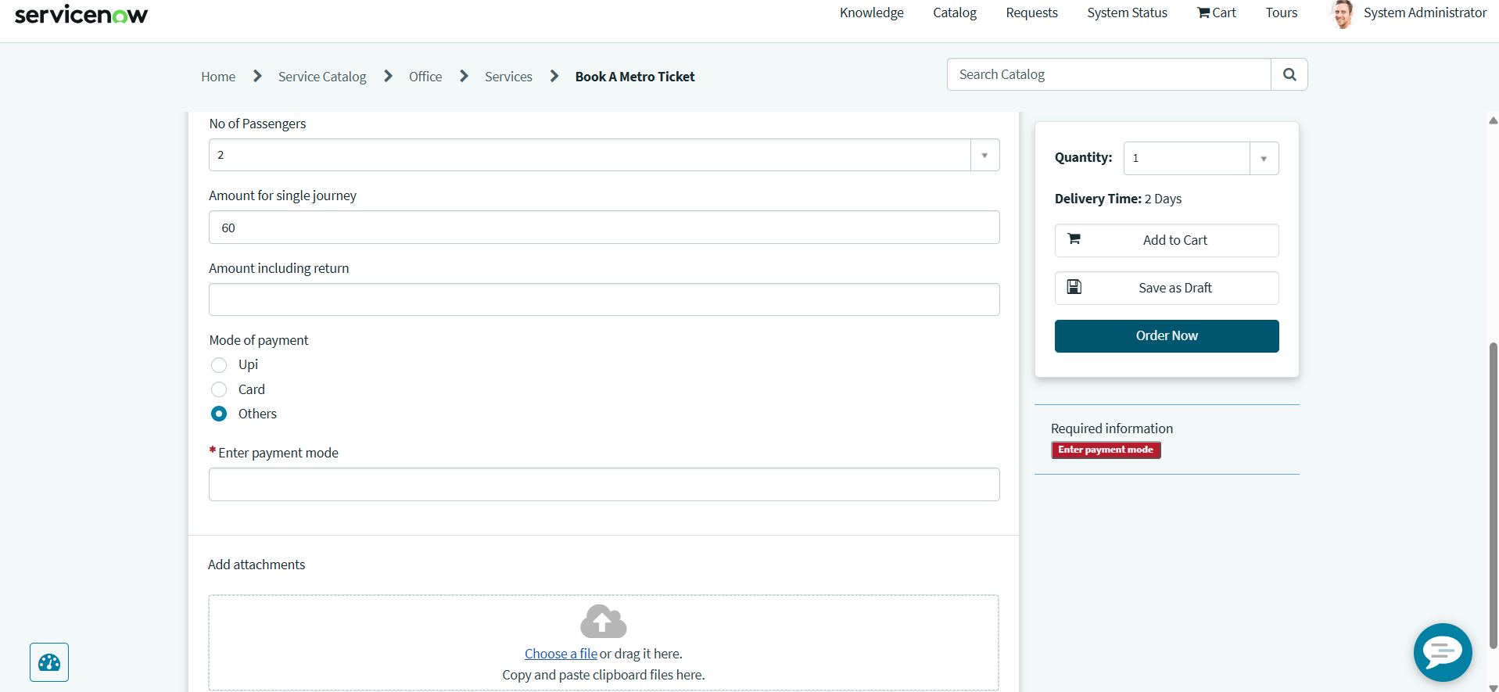
Starting Station, Destination, and Journey Details

Metro Ticket QR Code
After the booking process, the application displays the metro ticket QR code in a confirmation window. The QR code is intended to provide ticket information for scanning at the metro station gate, subject to the configured verification process.
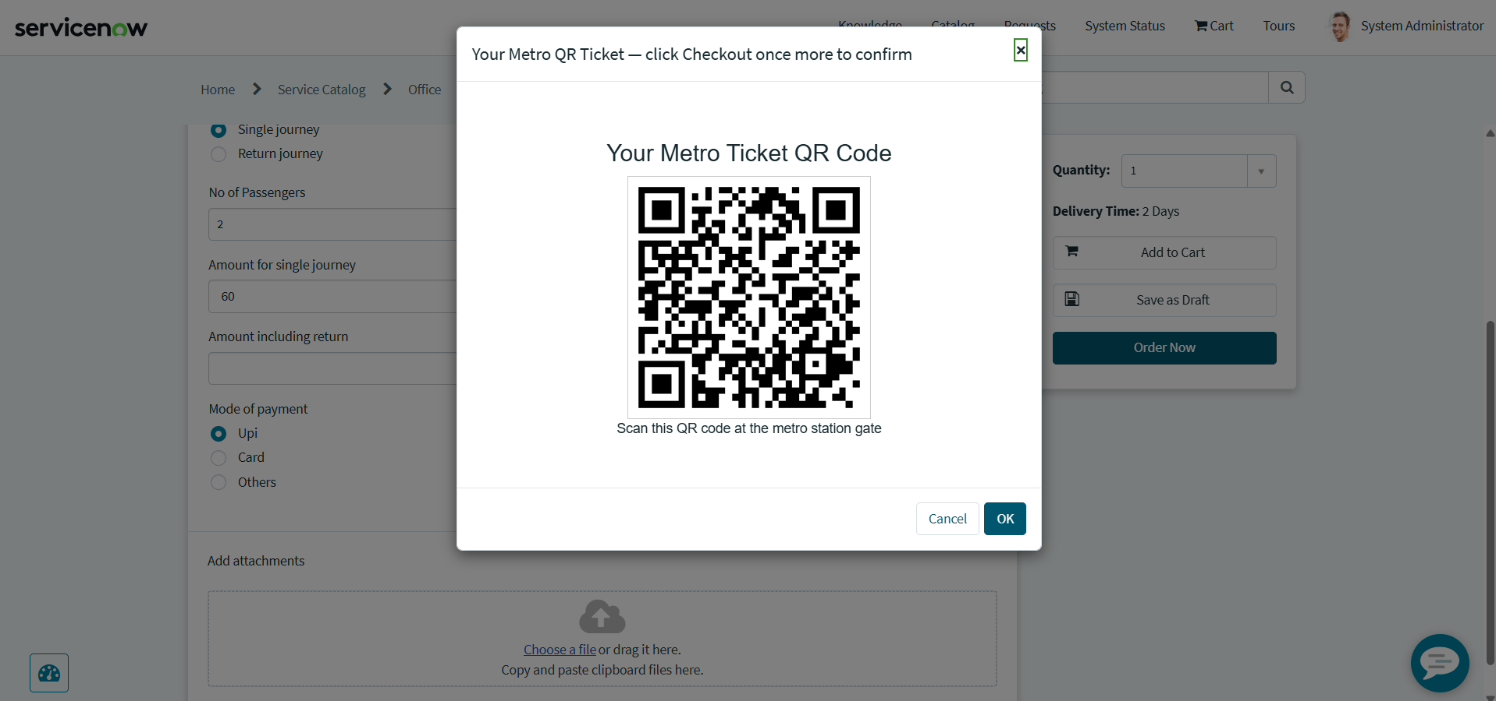
Generated Metro Ticket QR Code

5. Fare Details
The project includes configured fares for different metro station routes. The same configured fare is applied for the reverse direction of a route.
Route | Fare
Ameerpet - Panjagutta | ₹20
Ameerpet - Madhapur | ₹30
Ameerpet - Jubilee Hills | ₹20
Ameerpet - Kukatpally | ₹30
Ameerpet - LB Nagar | ₹50
Ameerpet - Uppal Stadium | ₹60
Panjagutta - Jubilee Hills | ₹20
Panjagutta - Madhapur | ₹30
Panjagutta - Kukatpally | ₹40
Panjagutta - LB Nagar | ₹50
Panjagutta - Uppal Stadium | ₹60
Jubilee Hills - Madhapur | ₹30
Jubilee Hills - Kukatpally | ₹40
Jubilee Hills - LB Nagar | ₹50
Jubilee Hills - Uppal Stadium | ₹60
Madhapur - Kukatpally | ₹40
Madhapur - LB Nagar | ₹50
Madhapur - Uppal Stadium | ₹50
Kukatpally - LB Nagar | ₹60
Kukatpally - Uppal Stadium | ₹70
LB Nagar - Uppal Stadium | ₹30

6. ServiceNow Configuration
- Service Catalog Item
- Catalog Variables
- Question Choices
- Catalog Client Scripts
- Catalog UI Policy
- Catalog UI Policy Action
- Service Portal Widget
- QR Code Generation
- Update Set

7. Update Set
The project configuration is captured in the Update Set named “Metro Ticket Generating System Project”.
The exported Update Set XML contains the required ServiceNow configuration for the metro ticket booking system, including the Catalog Item, Catalog Variables, Question Choices, Fare Calculation Script, QR Generation Script, Catalog UI Policy, Catalog UI Policy Action, and Service Portal QR Widget. The Update Set XML can be imported into another ServiceNow instance through Retrieved Update Sets.

8. Project Workflow
- Open the “Book A Metro Ticket” catalog item.
- Select the starting station.
- Select the destination station.
- Select the journey type.
- Select the number of passengers.
- Select the payment mode.
- The system automatically calculates the ticket fare.
- Click “Order Now”.
- The system displays the metro ticket QR code.
- The QR code can be scanned at the metro station gate, subject to the configured verification process.

9. Testing
The system can be tested with different station combinations, journey types, and passenger counts.
Example test:
- Starting From: Ameerpet
- Going To: Madhapur
- Journey Type: Single Journey
- Number of Passengers: 2
- Expected Fare: ₹30 × 2 = ₹60
- Return Journey Expected Fare: ₹30 × 2 × 2 = ₹120
QR-code display was also tested through the ticket booking flow.

10. Project Demo
Demo Video: https://drive.google.com/file/d/1mmVS-nIjkjaVGX6BOMe3p43MREBXuBk4/view?usp=sharing

11. Future Enhancements
- Online payment integration
- Ticket cancellation
- Booking history
- Automated email notifications
- Approval workflow
- Metro card recharge
- Reporting and dashboards
- Real-time metro service information

12. Conclusion
The ServiceNow Metro Ticket Generating System provides a structured and user-friendly way to submit metro ticket requests. It combines catalog variables, fare calculation, payment-mode selection, UI policies, and QR-code display to support the ticket booking workflow. The system can be extended with payment integration, ticket history, notifications, and QR verification.

